**COGNIZANT - DIGITALNURTURE4.0**

**DEEPSKILLING JAVA FSE**

**WEEK 02: SL4J LOGGING EXERCISE**

**EXERCISE 1: LOGGING ERROR MESSAGES AND WARNING LEVELS**

**Directory Structure**

LoggingMsg/

├── pom.xml

├── src/

│ └── main/

│ └── java/

│ └── com/

│ └── example/

│ └── LoggingExample.java

**pom.xml**

<dependencies>

<!-- SLF4J API -->

<dependency>

<groupId>org.slf4j</groupId>

<artifactId>slf4j-api</artifactId>

<version>1.7.30</version>

</dependency>

<!-- Logback Classic (SLF4J binding) -->

<dependency>

<groupId>ch.qos.logback</groupId>

<artifactId>logback-classic</artifactId>

<version>1.2.3</version>

</dependency>

</dependencies>

**LoggingExample.java**

package com.example;

import org.slf4j.Logger;

import org.slf4j.LoggerFactory;

public class LoggingExample {

private static final Logger logger = LoggerFactory.getLogger(LoggingExample.class);

public static void main(String[] args) {

logger.error("This is an error message");

logger.warn("This is a warning message");

}

}

**OUTPUT**

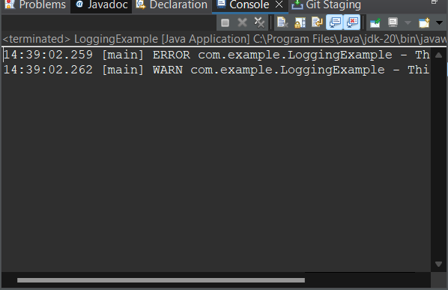

**NAME: HARINI G  
SUPERSET ID: 6385037**